**YEAR 10 SCIENCE EXTENSION**

**EXAM**

**2018**



**Please do not mark/write in the question booklet.**

# TIME ALLOWED FOR THIS PAPER

## Reading time before commencing work: ten minutes

Working time for the paper: 1 hour 30 minutes

# MATERIALS REQUIRED/RECOMMENDED FOR THIS PAPER

**To be provided by the supervisor:**

Multiple-choice Question Booklet

Question/Answer Booklet

Data Sheet

**To be provided by the candidate:**

Standard items: pens (blue/black preferred), pencils (including coloured), sharpener,

eraser, ruler, highlighters

Special items: non-programmable calculator

# IMPORTANT NOTE TO STUDENTS

No other items may be taken into the examination room. It is **your** responsibility to ensure that you do not have any unauthorised notes or other items of a non-personal nature in the examination room. If you have any unauthorised material with you, hand it to the supervisor **before** reading any further.

**Structure of this paper**

|  |  |  |  |  |
| --- | --- | --- | --- | --- |
| Section | Number of questions available | Number of questions to be answered | Suggested working time  (minutes) | Marks available |
| Section One:  Multiple-choice | 20 | 20 | 20 | /20 |
| Section Two:  Short answer | 8 | 8 | 47 | /43 |
| Section Three:  Extended answer | 1 | 1 | 22 | /22 |
|  | | | | /85 |

**Instructions to candidates**

1. Answer the questions according to the following instructions.

Section One: Answer all questions on the front of the separate Answer Booklet provided. **For each questions put a cross (X) in the box to indicate your answer. Use only a blue or black pen to mark the boxes.** If you make a mistake, shade that square then put a cross on your new answer. Do not erase or use correction fluid/tape. Marks will not be deducted for incorrect answers. No marks will be given if more than one answer is completed for any question.

Sections Two and Three: Write your answers in the Question/Answer Booklet.

2. **When calculating numerical answers, show your working or reasoning clearly**. Express numerical answers to the appropriate number of significant figures and include appropriate units where applicable.

3. You must be careful to confine your responses to the specific questions asked and to follow any instructions that are specific to a particular question.

4. Remember to use pencil and ruler for all diagrams. Include clear labels and titles where appropriate.

**Multiple Choice Section. Answer in the booklet provided. 17 marks.**

1. 1) A 90 N force is applied to a 65 kg mass. The mass will accelerate at:

A 0.72 m/s2

B 1.2 m/s2

C 1.4 m/s2

D 5.9 m/s2

1. 2) A skydiver glides to the ground at a steady speed of 7 metres per second. Which statement below best describes what is happening?
   1. The upward force of air resistance acting on the skydiver is smaller than the downward weight force that is acting
   2. The upward force of air resistance that is acting on the skydiver is larger than the size of the downwards weight force
   3. The upward force of air resistance balances the downwards force of gravity acting on the skydiver

D The weight force that acts on the skydiver is larger than the upwards force of air

resistance.

1. 3) Which of the following is best explained by Newton’s third law?
   1. Unbelted passengers will be thrown forward when a car stops suddenly.
   2. A gun recoils when a shot is fired.
   3. The acceleration of an object when a force is applied depends on the mass of the object.

D The weight of an object varies from planet to planet.

4) Examine the diagram of the water cycle shown. Identify the processes occurring at 1, 2, 3, 4 and 5 in that order.

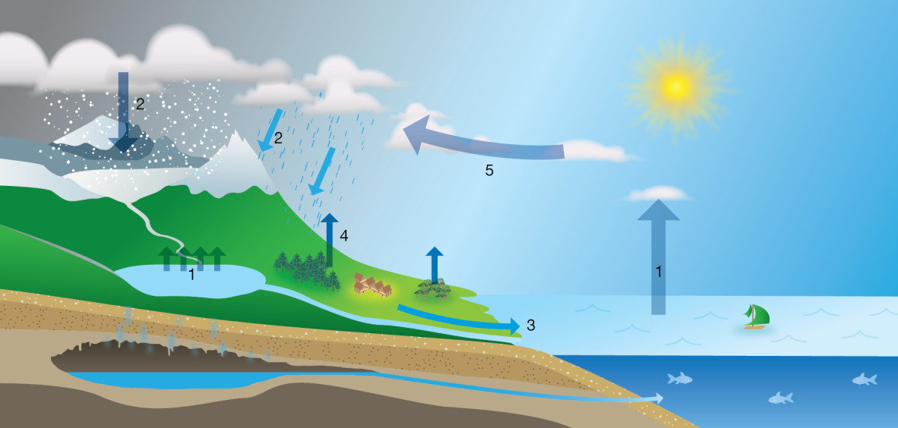

A Evaporation; precipitation; run-off; condensation; transpiration

B Precipitation; evaporation; transpiration; condensation; run-off

C Evaporation; precipitation; run-off; transpiration; condensation

D Transpiration; condensation; run-off; precipitation; evaporation

1. 5) Identify the best description of global warming.

A Periods of global warming occur between periods of glaciation

B Greenhouse gases in the atmosphere cause global warming

C Global warming began after the Industrial Revolution

D During periods of global warming sea levels fell exposing more land.

1. 6) Describesustainable ecosystems.

A Ecosystems that provide many different resources for humans

B Stable ecosystems that have survived unchanged for thousands of years

C Diverse ecosystems that provide for the needs of the organisms that live there

D Ecosystems that survive without any input from humans

1. 7) Which statement does NOT describe greenhouse gases or the effect they have?

A Nitrogen and oxygen are greenhouse gases that absorb the short-wave radiation coming into Earth’s atmosphere from the Sun.

B Water vapour and carbon dioxide in the atmosphere have no effect on the short-wave radiation coming into Earth’s atmosphere from the Sun.

C Greenhouse gases trap heat close to the surface of the Earth keeping it warmer than it would be without those gases.

D Carbon dioxide and methane absorb long-wave radiation and re-emit it in all directions

including back to Earth.

8) Identify the list that contains some of the main causes of ocean currents.

A Temperature, variations in salinity and revolution of the Earth around the Sun.

B Variations in salinity, rotation of the Earth and position of continents.

C Wind, position of continents and gravitational pull of the Sun and Moon.

D Gravitational pull of the Sun and Moon, temperature and rotation of the Earth.

1. 9) What is an UNLIKELY effect of global warming?

A Plants found on mountain tops will extend their range towards the lower slopes and valleys.

B Winters become shorter in many places so that the growing season is increased.

C Melting ice causes sea levels to rise inundating low lying areas.

D Animals found in warm seas will extend their range away from the equator and

go towards the poles.

10) Copper reacts with sulfur dioxide to form copper sulfide and oxygen gas. The reactants for this reaction are:

A. copper

B. copper and sulfur dioxide

C. copper sulfide and oxygen gas

D. copper, sulfur dioxide, copper sulfide and oxygen gas

11). When petrol explodes, it releases energy in the form of heat and light. This reaction is an example of:

A. an endothermic reaction

B. an exothermic reaction

C. a neutralisation reaction

D. a corrosion reaction

1. 12) Which product in the following chemical reaction is dissolved in solution?

CaCO3(s) + 2HCl(aq) → CaCl2(aq) + CO2(g) + H2O(l)

A HCl

B CaCl2

C CO2

D H2O

1. 13) The following word equation is NOT balanced, however, the formulae are correct   
    in only one of them Which one?
2. iron(III) oxide + carbon monoxide → iron + carbon dioxide

A Fe2O3 + CO → Fe + CO2

B FeO + CO → Fe + CO2

C Fe2O3 + CO2 → Fe + CO

D FeO + CO2 → Fe + CO

1. 14) Which of the following equations is balanced?

A C2H6 + O2 → CO2 + H2O

B C2H6 + O2 → 2CO2 + 3H2O

C C2H6 + 7O2 → 2CO2 + 3H2O

D 2C2H6 + 7O2 → 4CO2 + 6H2O

1. 15) Which of the following chemical reactions is a combination reaction?

A 2H2O(l) → 2H2(g) + O2(g)

B 2H2(g) + O2(g) → 2H2O(l)

C H2O2 → H2 + O2(g)

D H2O + Na → NaOH + H2

1. 16) Which is the best term to describe the following reaction?
2. CaCO3(s) → CaO(s) + CO2(g)

A Combination reaction

B Metal displacement reaction

C Precipitation reaction  
D Decomposition reaction

1. 17) When solutions of sodium chloride (NaCl) and silver nitrate (AgNO3) are mixed, solid silver chloride (AgCl) forms. Which ions remain dissolved in the solution?

A Na+ and Cl−

B Ag+ and Cl−

C Na+ and 

D Ag+ and 

1. 18) Explain why crushing solid reactants helps to increase the rate of reaction.

A It exposes more of the solid reactant to the other reactants so there can be more reactions occurring at any one time.

B It weakens the chemical bonds in the solid so that it is easier for the reaction to occur.

C It helps the solid to dissolve.

D All answers are correct.

1. 19) Explain why adding a catalyst to a reaction increases the rate of reaction.

A The catalyst can provide a pathway for the chemical reaction that requires less energy.

B The catalyst can help the reactant molecules to come together and react.

C The catalyst can force reactants into the correct arrangement so that they react.

D All answers are correct.

20) The Law of Conservation of mass explains why, in a chemical reaction:

A. energy cannot be created nor destroyed, only transformed or transferred.

B. the total mass of reactants equals the total mass of products.

C. new atoms are created from the reactant atoms.

D. when rearranging atoms to form products, the mass changes significantly



**SEMESTER 2 2018**

**YEAR 10 SCIENCE EXTENSION EXAM:**

**ANSWER BOOKLET**

**NAME:**

**FORM: DATE:**

**Multiple Choice Short Answer Extended Answer Total**

**/85**

**/12**

**/47**

**/20**

**SECTION ONE: Multiple choice answers**

**Cross (X) through the correct answer.**

|  |  |  |  |  |  |  |  |  |  |  |
| --- | --- | --- | --- | --- | --- | --- | --- | --- | --- | --- |
| **1** | **a** | **b** | **c** | **d** |  | **11** | **a** | **b** | **c** | **d** |
| **2** | **a** | **b** | **c** | **d** |  | **12** | **a** | **b** | **c** | **d** |
| **3** | **a** | **b** | **c** | **d** |  | **13** | **a** | **b** | **c** | **d** |
| **4** | **a** | **b** | **c** | **d** |  | **14** | **a** | **b** | **c** | **d** |
| **5** | **a** | **b** | **c** | **d** |  | **15** | **a** | **b** | **c** | **d** |
| **6** | **a** | **b** | **c** | **d** |  | **16** | **a** | **b** | **c** | **d** |
| **7** | **a** | **b** | **c** | **d** |  | **17** | **a** | **b** | **c** | **d** |
| **8** | **a** | **b** | **c** | **d** |  | **18** | **a** | **b** | **c** | **d** |
| **9** | **a** | **b** | **c** | **d** |  | **19** | **a** | **b** | **c** | **d** |
| **10** | **a** | **b** | **c** | **d** |  | **20** | **a** | **b** | **c** | **d** |

**SECTION TWO: SHORT ANSWER (47 marks)**

18. Classify the following as situations in which forces are balanced or unbalanced.

a. A motor bike accelerating away from traffic lights. (1 mark)

b. A car travelling at a constant 100 kmh-1 straight down a freeway. (1 mark)

19 a. A short form of Newton’s First Law is ***inertia***. Explain what inertia is and how it relates to the mass of an object. (2 marks)

b. Cars have many safety features that protect people in cars from the effects of inertia. Name 2 and explain how they work. (2 marks)

___________________________________________________________________

___________________________________________________________________

___________________________________________________________________

___________________________________________________________________

___________________________________________________________________

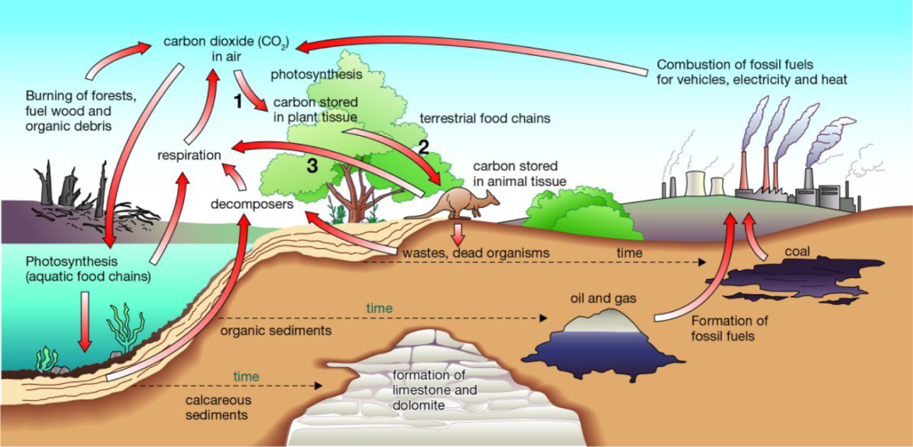

Figure 1

Part of the carbon cycle

20. The diagram above represents part of the carbon cycle. (6 marks)

**a Construct** a statement for each of the numbered arrows, describing what happens at that step.

**a 1** Plant uses carbon dioxide (CO2) in photosynthesis.

**2** Plants become food for herbivores; carbon compounds present in plants become incorporated into animals’ tissues.

**3** Cellular respiration produces CO2 as a by-product, which is released back into the atmosphere.

**b Explain** why the recycling of materials is important to the continued functioning of ecosystems. (2 marks)

Recycling of materials ensures that substances become available again for use by plants and animals in the ecosystem. If materials were not recycled but were locked up in the dead remains of plants and animals, fewer and fewer resources would be available for new organisms. Eventually life would cease to exist.

1. **21. Explain** how each of the following can be used as evidence of climate past change. (3 marks)

**a** ice cores

***On some glaciers and ice sheets, sufficient snow falls each year to form recognisable annual layers. Scientists take cores from the ice and then analyse its physical and chemical properties. The analysis provides information about temperatures and the composition of the air from hundreds of thousands of years in the past***

**b** sedimentary rocks

***The worldwide distribution of sedimentary rocks and the types of fossils found in them are indicators of changes in sea level in the past. For example, sedimentary rocks in the dry area of central Australia contain fossils of sea creatures***

**c** glaciers

**c *Glaciers advance when the climate cools and retreat when the climate warms.***

***As glaciers move, they grind against the rocks on the sides and floor of the valley through which they flow. The rocks on the side of the valley are deeply scored by broken rocks being dragged along the sides and base of the glacier. When the glacier retreats, the scoring of the rocks becomes visible. Scoring in the rock and the presence of moraines indicates where there have been glaciers in the past.***

1. 22. The production of iron metal from iron ore uses a complex series of reactions that all take place within a blast furnace. The reactions are:

A 2C + O2 → 2CO

B Fe2O3 + CO → Fe + CO2

C CaCO3 → CaO + CO2

D SiO2 + 2CaO → Ca2SiO4

1. **Identify** which of these reactions are: (3 marks)

a combination reactions

b decomposition reactions

c combustion reactions

**a: *A and D***

**b**: ***C***

**c:** ___***A and B***_______________________________________________________________

23. Give the name or chemical formula for the following compounds: (6 marks)

1. Magnesium hydroxide ***Mg(OH)2***
2. CO3  ***carbonate***
3. Ammonium sulfate ***(NH4)2SO4***
4. NH3 ***ammonia***
5. Aluminium oxide ***Al2O3***
6. Sulfuric acid ***H2SO4***

24. Balance the following equations. Be aware that spaces do not necessarily have to be filled. (4 marks)

1. _____ Fe + __***2*** AgNO3 🡪 _____ Fe(NO3)2 + ***2***Ag
2. _____ S8 + ***8***O2 🡪 ***8***SO2
3. _____V2O5 + ***5***CaS 🡪 ***5***CaO + _____V2S5

d) ***6***AgI + _____ Fe2(CO3)3 🡪 ***2***FeI3 + ***3*** Ag2CO3

24.

A. Complete the following word equations: (3 marks)

Acid + Base ***→ salt + water***

Acid + Metal → ***Salt + hydrogen gas***

Acid + Carbonate → ***carbon dioxide gas + salt + water***

B) Write balanced equations for the following reactions: (9 marks)

**Hydrochloric acid and calcium carbonate**

Word equation:

***Hydrochloric acid + calcium carbonate → calcium chloride + carbon dioxide + water.***

Chemical equation:

***HCl + CaCO3 → CaCl2  + CO2 + H2O***

Balanced equation:

***2 HCl + CaCO3  → CaCl2 + CO2 + 2H2O***

**Magnesium and sulfuric acid.**

Word equation:

***Magnesium and sulfuric acid → magnesium sulfate + hydrogen gas.***

Chemical equation :

***Mg +H2SO4 →MgSO4 + H2***

Balanced equation:

***Mg + H2SO4 →MgSO4 + H2***

**Hydrochloric acid and sodium hydroxide.**

Word equation:

Hydrochloric acid +

Chemical equation :

***HCl + NaOH → NaCl + H2O***

Balanced equation:

***2HCl + 2(NaOH) → 2NaCl + 2H2O***

25. Use the solubility table provided for each of the following chemical reactions   
 (5 marks)

1. Determine whether or not a precipitate will form;
2. If a precipitate forms, write the chemical formula for this solid.
3. Write the balanced ionic equation for those reactions which will produce a precipitate.

(If no precipitate forms write **no reaction**)

1. lead (ll) nitrate and sodium iodide

***precipitate is PbI2 (1 mark)***

***Pb2+ + 2I-🡪 PbI2 (1 mark)***

1. sodium hydroxide and magnesium nitrate

***precipitate is Mg(OH)2 (1 mark)***

***Mg2+ + 2OH-🡪 Mg(OH)2 (1 mark)***

c) ammonium nitrate and potassium phosphate

***no reaction (1 mark)***

**SECTION THREE: EXTENDED ANSWER SECTION**  **(12 marks)**

Define rate of reaction and identify the main factors that control the rate of reaction. Explain in terms of the collision theory how these factors increase the reaction rate. Provide definitions where appropriate. Give examples where these increasing rates of reactions are applicable in the real world.

Definition

___________________________________________________________________

___________________________________________________________________

___________________________________________________________________

Factors that affect the rate of reaction

1) ___________________________

Explanation/Definition

___________________________________________________________________

___________________________________________________________________

___________________________________________________________________

Example

___________________________________________________________________

___________________________________________________________________

___________________________________________________________________

2) ___________________________

Explanation/Definition

___________________________________________________________________

___________________________________________________________________

___________________________________________________________________

Example

___________________________________________________________________

___________________________________________________________________

___________________________________________________________________

3)__________________________

Explanation/Definition

___________________________________________________________________

___________________________________________________________________

___________________________________________________________________

Example

___________________________________________________________________

___________________________________________________________________

___________________________________________________________________

4) _________________________

Explanation/Definition

___________________________________________________________________

___________________________________________________________________

___________________________________________________________________

Example

___________________________________________________________________

___________________________________________________________________

___________________________________________________________________

5) _____________________

Explanation/Definition

___________________________________________________________________

___________________________________________________________________

___________________________________________________________________

Example

___________________________________________________________________

_____________________________________________________________________

_____________________________________________________________________